**CSE 204**

**DATA STRUCTURES AND ALGORITHM**

**SESSIONALS**



**OFFLINE NO : TWO (Problem 2)**

**TITTLE : Power set algorithm implement and analysis**

**SUBMITTED BY :**

**FAHMID - AL-RIFAT**

**STUDENT NO : 1705080**

LEVEL-2 ,TERM-1

DEPARTMENT OF CSE

BUET

**OBJECTIVE:** The objective of offline is to generate all distinct subsets of

given a set S and find distinct power set of set S where various size of set are randomly generated with characters and numbers .

**MACHINE CONFIGURATION:**

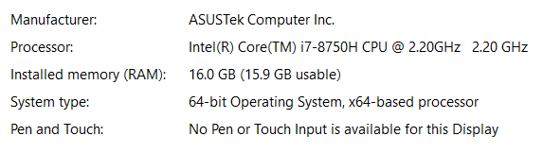

Code::Blocks 17.12

**DATA SET :**

**Table of sort algorithm time in millisecond and array size:**

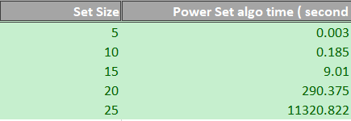

**DISCUSSION :**

A **set** is a collection of distinct objects . Here array is taken to save the distinct object like characters and numbers which are randomly generated.

The power set of a set *S* is the set of all subsets of *S*.If there are n elements in set the number of power set is **2n** . In here to get the all subset by using bit wise combination and thus the complexity of the algorithm become **O(n*2n)** as printing need extra n time traversing loop . As the input size increases the time needed for printing the algorithm increases at **2n**

Rate .

